ITB PAGES TO FIX:
- https://habke.art/concrete/ Not loading done
- https://habke.art/precast/ Header is in different color: done
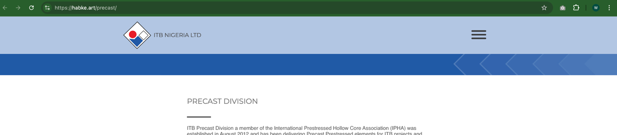
- Menu bar: please make the titles bigger done
- https://habke.art/aluminum/ Not loading done
- https://habke.art/capabilities/ remove the inquiry button done
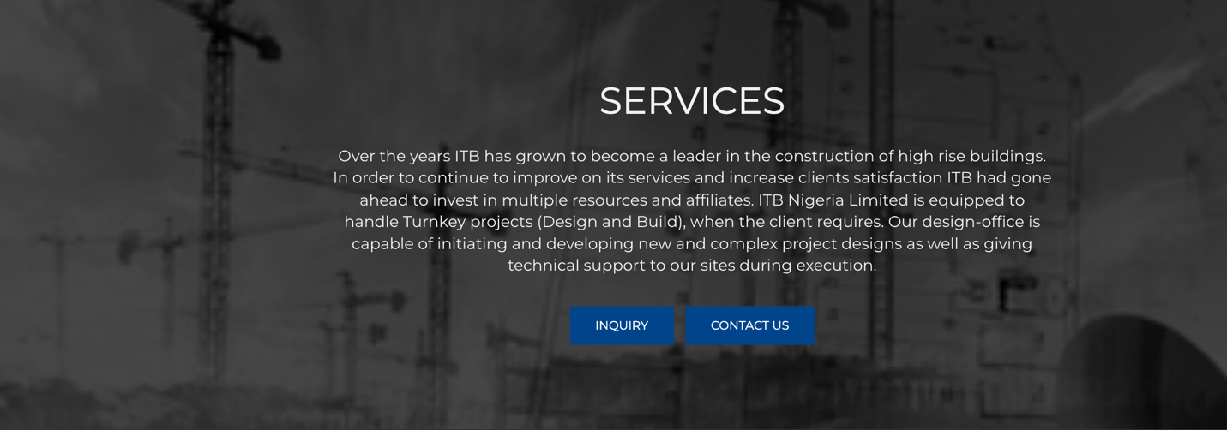
- https://habke.art/whistleblower-report-form/ add the footer in this page and please the text should be “ ITB NIGERIA LIMITED – ALL RIGHTS RESERVED 2026” For all the pages. done
- https://habke.art/marine-projects/ Please change the name of the titles done
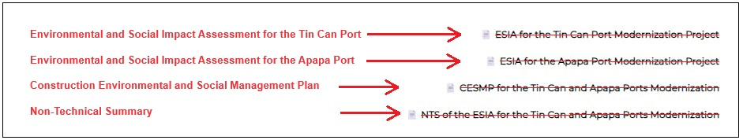

Also fix the last 4 images done
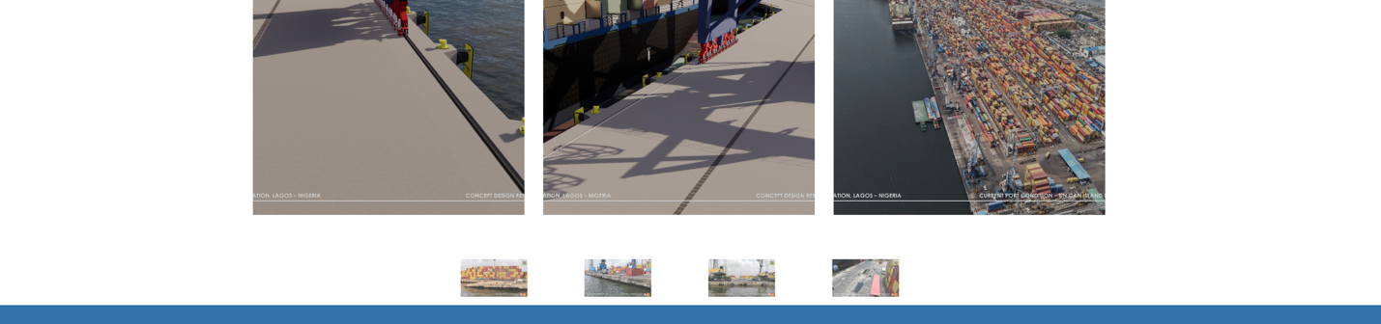
- https://habke.art/fit-out-projects/ link the projects to the sub pages done
- https://habke.art/construction-projects/ link the projects to the subpages done

